National Outstanding Achievement Award Application
Revised: 10/24

Please Note:
- Local Chapters: Email to your state office in accordance with state deadlines of Nov 1^{st.} to tcostello@wisconsinffaalumni.org
- At the National Level, Local Alumni and Supporters Chapters and Collegiate Alumni and Supporters Chapters are judged and awarded separately.
- Local Chapters are responsible for submitting the application to national by July 1st via the link: https://www.ffa.org/alumni-and-supporters/chapter-opportunities/
- This National application is subject to change.
- Applications must be typed.
- No additional pages may be added.
- Keep a copy of the application for your records, as the application will not be returned.
- Recipients may be asked to send a picture for use by the National FFA Organization.
- An activity may be listed only once.
- The FFA Alumni and Supporters Resource Guidebook can be a useful tool for completing the application (can be found at FFA.org/alumni.)
- By submitting this application, you are providing National FFA permission to share the events and programs listed on the application.
- If not selected for this award, you may reapply annually.
- Award recipients may only receive this award once.

Has nominee ever been employed as a teacher, state staff, or teacher educator of agricultural education?

NO
Yes or No?

Name of Nominee: | Frank Kuzma

Mailing Address: | W12905 Juniper Dr

City: | Lodi | State: | WI | Zip: | 53555

Phone: | 608-566-9451 | Ext: |  | Fax:

Phone/Email: | fwkuzma@gmail.com

Title or Occupation of Nominee: | Gillian Hacker- Alumni Board Member
Alumni Chapter/Alumni Chapter ID: |  | Sauk Prairie FFA Alumni and Supporters

Wisconsin
Nominated by the state of:

State Alumni Leader Phone/Email:
_______________________________________ _____________________________________
State FFA Alumni President or Executive Director Date Submitted

Involvement (50 points total)

Responses are open to, but not required to be, involvement at the local, state and national levels.

- (10 points) In what ways has the nominee demonstrated outstanding achievement through Business Operations for Alumni and Supporters in the areas of premier leadership and stewardship?
Frank has shown exceptional leadership and dedication to the Sauk Prairie FFA Alumni and Supporters through his consistent involvement and commitment to the success of the organization. He takes on leadership and chaperone roles for student events, helps plan and work fundraisers—including those that provide new students with their first FFA jacket—and volunteers at nearly every event. Frank also supports students by hosting those completing their student teaching and by teaching hunter safety courses. Known and respected by everyone, he builds strong relationships with members, new supporters, and donors alike, demonstrating true stewardship and leadership within the FFA community.

- (10 points) In what ways has the nominee demonstrated outstanding achievement through FFA Alumni and Supporters Member Development in the areas of recruiting new Alumni and Supporters and providing member development opportunities for existing Alumni and Supporters members?
Frank has played a key role in strengthening the Sauk Prairie FFA Alumni and Supporters through his efforts to recruit new members and support the growth of existing ones. His friendly, welcoming nature encourages community members, parents, and former students to get involved, and he takes the time to connect personally with potential new members and vendors. Frank actively promotes the value of the Alumni organization at events and fundraisers, helping others see the impact their involvement can make. For current members, he leads by example—offering guidance, sharing his knowledge from years of experience, and creating opportunities for others to grow and take on leadership roles.

- (10 points) In what ways has the nominee demonstrated outstanding achievement through Advocacy for Agricultural Education in the areas of community support, school officials support and community service?
Frank is a passionate advocate for agricultural education and continually works to build strong connections between the community, school, and FFA program. He supports students by volunteering at events, chaperoning activities, coaching CDE, and helping raise funds that directly benefit agricultural education. Frank’s involvement and reputation within the community help strengthen support from local businesses, donors, and school officials. Through his volunteer work, including teaching hunter safety and mentoring students, he consistently promotes the importance of agricultural education and community service, ensuring continued growth and respect for the FFA program

- (10 points) In what ways has the nominee demonstrated outstanding achievement through Agricultural Education/FFA Program Development in the areas of student recruitment, cooperation, teacher support, and financial support?
Frank has graciously opened his home to student teachers completing their time in our schools, offering them a warm welcome and valuable guidance throughout their experience. He takes the time to introduce them to the Sauk Prairie community, sharing his knowledge and insight gained through many years of involvement with the FFA chapter. Frank’s support helps new agricultural educators feel connected and confident as they begin their teaching careers. His commitment to fostering cooperation between students, teachers, and community members—along with his continued efforts in fundraising and program support—makes him an invaluable part of the ongoing success and growth of our agricultural education and FFA programs.

- (10 points) In what ways has the nominee demonstrated outstanding achievement through Student Development in the areas of student leadership, personal growth and career success?
Frank has shown a strong commitment to student development by volunteering his time to coach CDE teams and assist with the in-school Hunter Safety course. Through these activities, he helps students build leadership skills, confidence, and practical knowledge that contribute to their personal growth and future success. Frank is always willing to give his time and energy to support students, never hesitating to lend a hand whenever needed. His reliability, encouragement, and genuine care for student achievement make him an outstanding role model and a vital part of the Sauk Prairie FFA community.

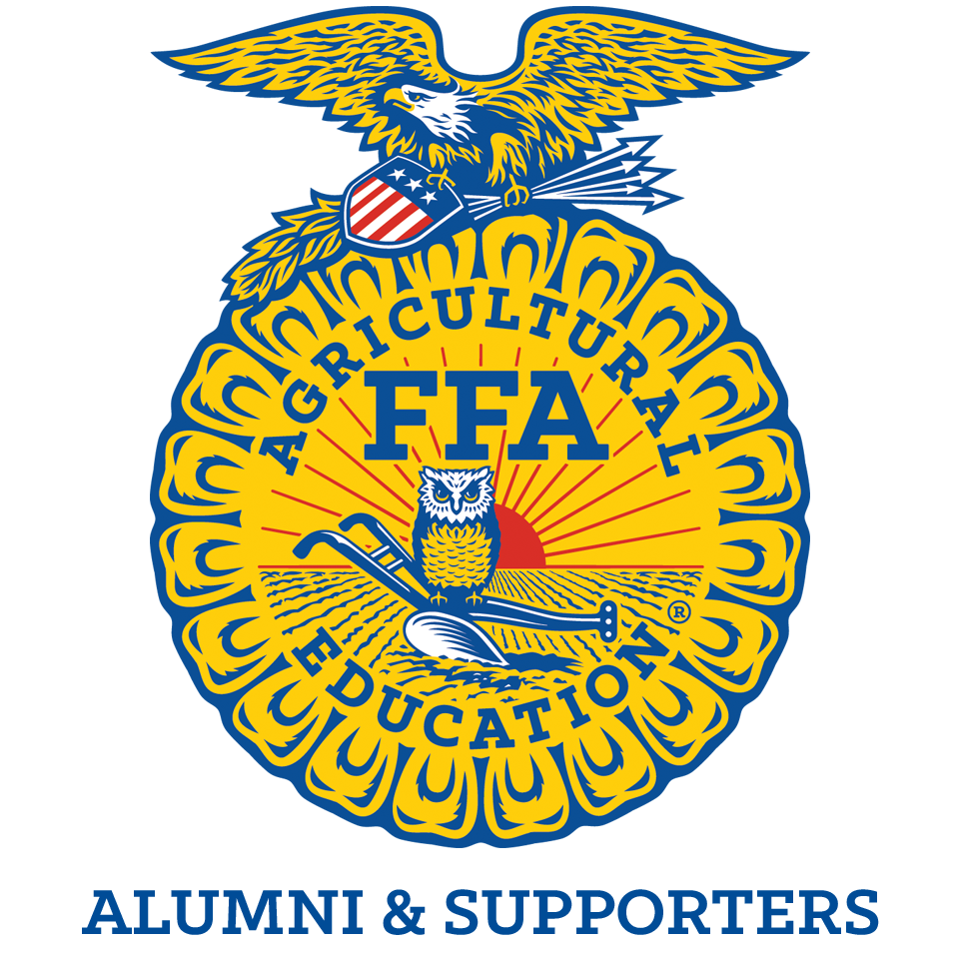
Outstanding Achievement Award Application Scorecard

Category | Points Possible | Points Awarded
Involvement:  Business Operations | 10
Involvement:  Alumni Member and Supporters Development | 10
Involvement:  Advocacy for Agricultural Education | 10
Involvement:  Agricultural Education/FFA Program Development | 10
Involvement:  Student Development | 10
TOTAL | 50

