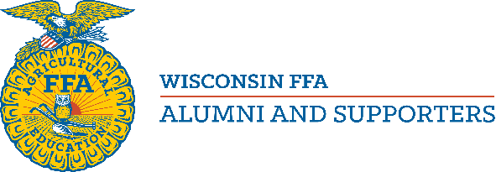

Wisconsin Outstanding Young Member Award Application

Email to execdir@wisconsinffaalumni.org. Entry must be postmarked by Nov 1st.

The Wisconsin FFA Alumni and Supporters Association established the Outstanding Young FFA Alumni Member Award in 2016 to recognize the contributions and achievements of our members age 35 and younger.

It is the desire of the association to encourage younger members to participate more actively with the FFA Alumni at any level. At the same time the association recognizes that challenges for younger members to serve and we wish to publicly recognize those that have, with the hope that this will encourage other young members to consider the same.

Please complete the form below to nominate a Wisconsin FFA Alumni and Supporters member for recognition as the Outstanding Young FFA Alumni and Supporters Member for his or her contributions to the FFA Alumni and to the FFA. The nominee with the highest total score will be the winner. The winner will be announced at the Wisconsin FFA Alumni and Supporters Convention in February.
This award is only for members who are 35 years of age or younger on December 31 of the year of the application. A member is only eligible to win this award once.

Name of Nominee:
Nominee Birthdate:
Chapter of Membership:
City, Zip:
Email:
Phone:
Application prepared by:
City, Zip
Email:
Phone:
Signature: Date:

Nominee Information
List up to 5 ways the applicant has been involved with the FFA Alumni and Supporters. Include any involvement at the local, state and national levels. Be sure to include the number of years that the nominee has helped with each item listed. (Maximum points = 15 for each activity.)
Do not include serving as an FFA Alumni officer here.
1:
2:
3:
4:
5:
Describe up to 5 ways the applicant has been involved with the local, state or national FFA and agriculture education in general. (Maximum points = 10 for each activity.)
(Serving as a chaperone should be included in this list, not in question 3.)
1:
2:
3:
4:
5:
List up to 5 ways the applicant directly worked with FFA members and other agriculture students. Please include the number of FFA members that the applicant has worked with for each item listed. (Maximum points = 10 for each activity.)
1:
2:
3:
4:
5:
Please list if the applicant has served as a local FFA Alumni and Supporters officer and the offices held.

In 100 words or less, please state why you believe that the applicant should be considered for this award. (Maximum points 20 awarded by judge.)

